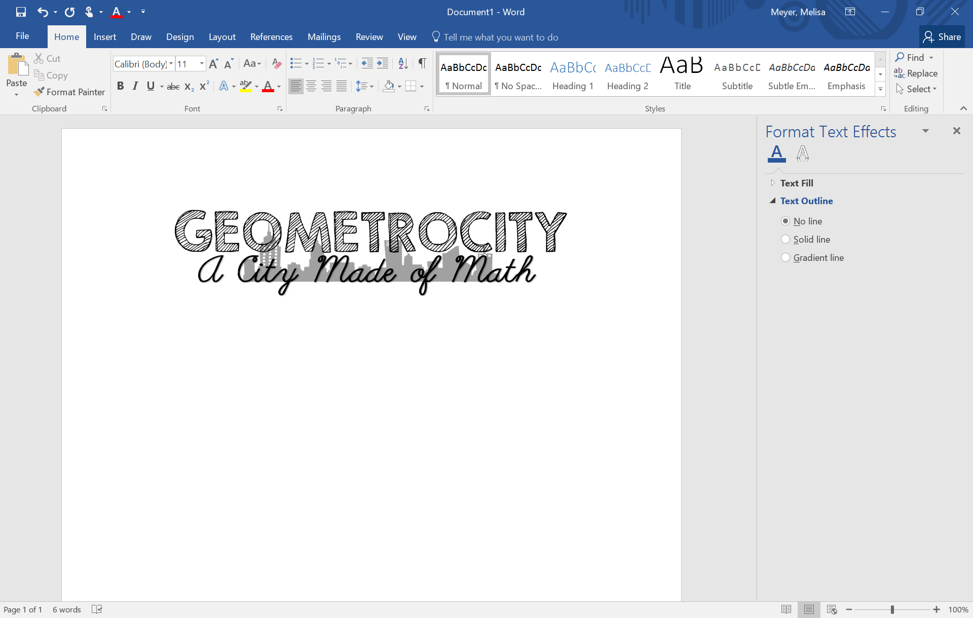

**To: Mr. Mayor and City Commissioner**

**Re: City Layout Rationale**

Our team of architects recently met to determine an appropriate layout for each of our individual map sections. We are proud to share our team’s rationale for the placement of each city section within our final layout.

Firstly, we discussed about how the “jail” next to the police station because the police officers need to be near the police station. This is because if someone tries to escape, they are right next to the jail, and it would be easier to catch the criminal. Also, the sewage treatment is right next to the jail because they need to learn the consequences of breaking the law. Secondly, the skyscraper is tall mall, and each floor is a different category. For example, the first floor can be the clothing section, and the second floor can be the food section, etc. Next, the restaurants have to be next the hotels and apartments because people need to have food right next to them, since the maybe some people don’t like the hotel or apartment food associated, so they go to a fast food or restaurant. After that, the banks and office buildings need to be right next to the parking lot because parking spaces for the banks and office building might be full, and if the parking space is full, people would have to park somewhere else that is near their location. That is why there should be a parking lot next to those crowded places. Then, we discussed about how the apartments should be next to the grocery store. We talked about this because since the people live at the apartments, they would need their source of food, water, and other resources that they will need. Also, our group decided that, the apartments and the hotels should be away from the zoo and sewage treatment center because people pay to stay, and people wouldn’t want to smell nasty stink, when they pay to stay. That is the summary of what we talked about.

Sincerely,

Ms. Mackenzie Frantzen, Mr. Kai Edward Staats, Mr. Quang Huynh